Pet Policy 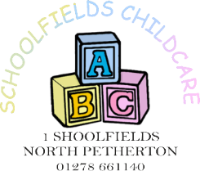

I am very fond of animals and like to keep pets. I currently own a dog called Molly and a cat called Nala. Molly is a very obedient, well trained Labrador/Collie who is used to being around children and enjoys their company.

I believe that children can benefit a great deal from being around and having contact with animals. Looking after a pet can teach children responsibility by allowing them to contribute to the pet’s daily care needs. I do however have the following procedures in place to ensure the safety of all:

- The children must wash their hands after contact with any animal. I explain to them the reasons behind this and encourage good hygiene wherever possible.
- I show children the correct way to treat animals and encourage them to treat them with respect.
- I explain to children that not all animals are friendly and that they should always check with the animal’s owner first to see if it is okay to stroke or handle them.
- I keep all pet food and other animal supplies in a locked cupboard to prevent the children from accessing it.
- I feed my pets in the kitchen, in an area where the children do not play, and ensure that any feeding or drinking bowls are kept out of reach from the children.
- I take good care of my pet and ensure he is kept clean, and free from pests.
- I check my garden thoroughly each day to ensure that no animal has fouled there before allowing children out to play.

If you have any queries regarding this policy or would rather your child was not involved in helping to care for my pet then please do not hesitate to discuss this with me.

December 2021
Kallie Valentine

